JACK O’ LANTERN COOKIES

1/2 cup margarine, softened
3/4 cup sugar
1 cup canned pumpkin
2 cups flour
1 teaspoon each, baking powder, baking soda, cinnamon
1/4 teaspoon salt

Prep time: 10 min. Cook time: 16 min. Makes 18 cookies.


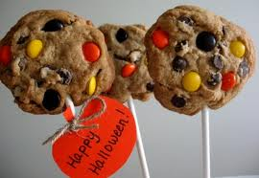

Preparation: 1Combine margarine, sugar, and pumpkin in large bowl; beat at medium speed of an electric mixer until light and fluffy. 2. In a medium, combine flour, baking powder, baking soda, cinnamon, and salt. Add to margarine mixture and beat at low speed until well blended. 3. Drop dough by heaping tablespoons (about 4 inches apart) onto lightly greased cookie sheets. Lightly press each cookie into a 3.5 inch circle with fingertips dipped in flour. 4. Bake at 375℉ for 16 minutes or until lightly browned. Cool cookies completely on wire racks. Frost with your favorite icing. Make into jack o’ lanterns using raisins, candy corn, M&Ms, etc.

Nutrition (per serving): 133 calories. 4g fat. 23g carbohydrate. 2g protein. 0 mg cholesterol. 193 mg sodium.

HALLOWEEN COOKIE POPS

1 box orange flavored cake mix
2 eggs
3/4 cup water
1 can cream cheese frosting
24 popsicle sticks

Prep time: 15 min. Cooking time: 10 min. Makes 3 dozen.

Preparation: 1. In a large bowl, mix together eggs, water, and cake mix with a fork until well blended. For each cookie, place 1 tablespoon of mix onto a greased cookie sheet. 3. Put a popsicle stick in each so it looks like a lollipop. 4. Bake at 350℉ for 10 minutes, cool then remove from cookie sheet. 5. Frost each cookie and enjoy.

Nutrition (per serving): 119 calories. 20g carbohydrate. 4g fat. 1g protein. 12 mg cholesterol. 131 mg sodium.

PEANUT POPCORN BALLS

1/3 cup packed brown sugar
1/3 cup corn syrup
2 tablespoons chunky peanut butter
5 cups popped Smart Pop Microwave Popcorn

Prep time: 10 min. Cook time: none. Makes 8 balls.

Preparation: Pop popcorn bag according to package directions. 2. In a microwave-safe bowl, combine brown sugar, corn syrup, and peanut butter. Microwave uncovered on HIGH 1 to 1.5 minutes or until the mixture begins to bubble. Stir well. 3 Stir mixture into popcorn until well coated. Let cool for 5 minutes. Press popcorn mixture into balls. Eat right away or wrap in plastic to store.

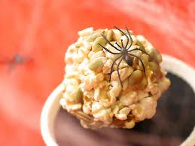
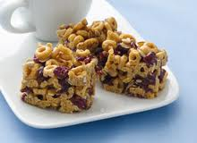
Nutrition (per serving): 226 calories. 11g fat. 27g carbohydrate. 5g protein. 10 mg cholesterol. 455 mg sodium. 1g fiber.

HALLOWEEN CEREAL BAR

6 cups Cheerios
3 tablespoons butter
40 marshmallows*
1 cup raisins or chopped dried apricots
1 cup slivered almonds

Prep time: 10 min. Cook time: 20 min. Serves 12.

Preparation: 1. In large saucepan melt butter over low heat. Add marshmallows and stir until completely melted. Remove from heat. 2. Add Cheerios, raisins, and almonds. Stir until well coated. 3. Using buttered spatula or wax paper evenly press mixture into 13 x 9 x 2-inch pan coated with cooking spray. Cool. Cut into 2-inch squares. Best if served the same day.

Nutrition (per serving): 250 calories. 8g fat. 44g carbohydrate. 4g protein. 10mg cholesterol. 150 mg sodium. 3g fiber.

*Note: Researching for sugar free marshmallows

